3RD ANNUAL

RECOGNITION LUNCHEON

HONORING OUR SEASONED COMMUNITY TREASURES

(90 YEARS+)

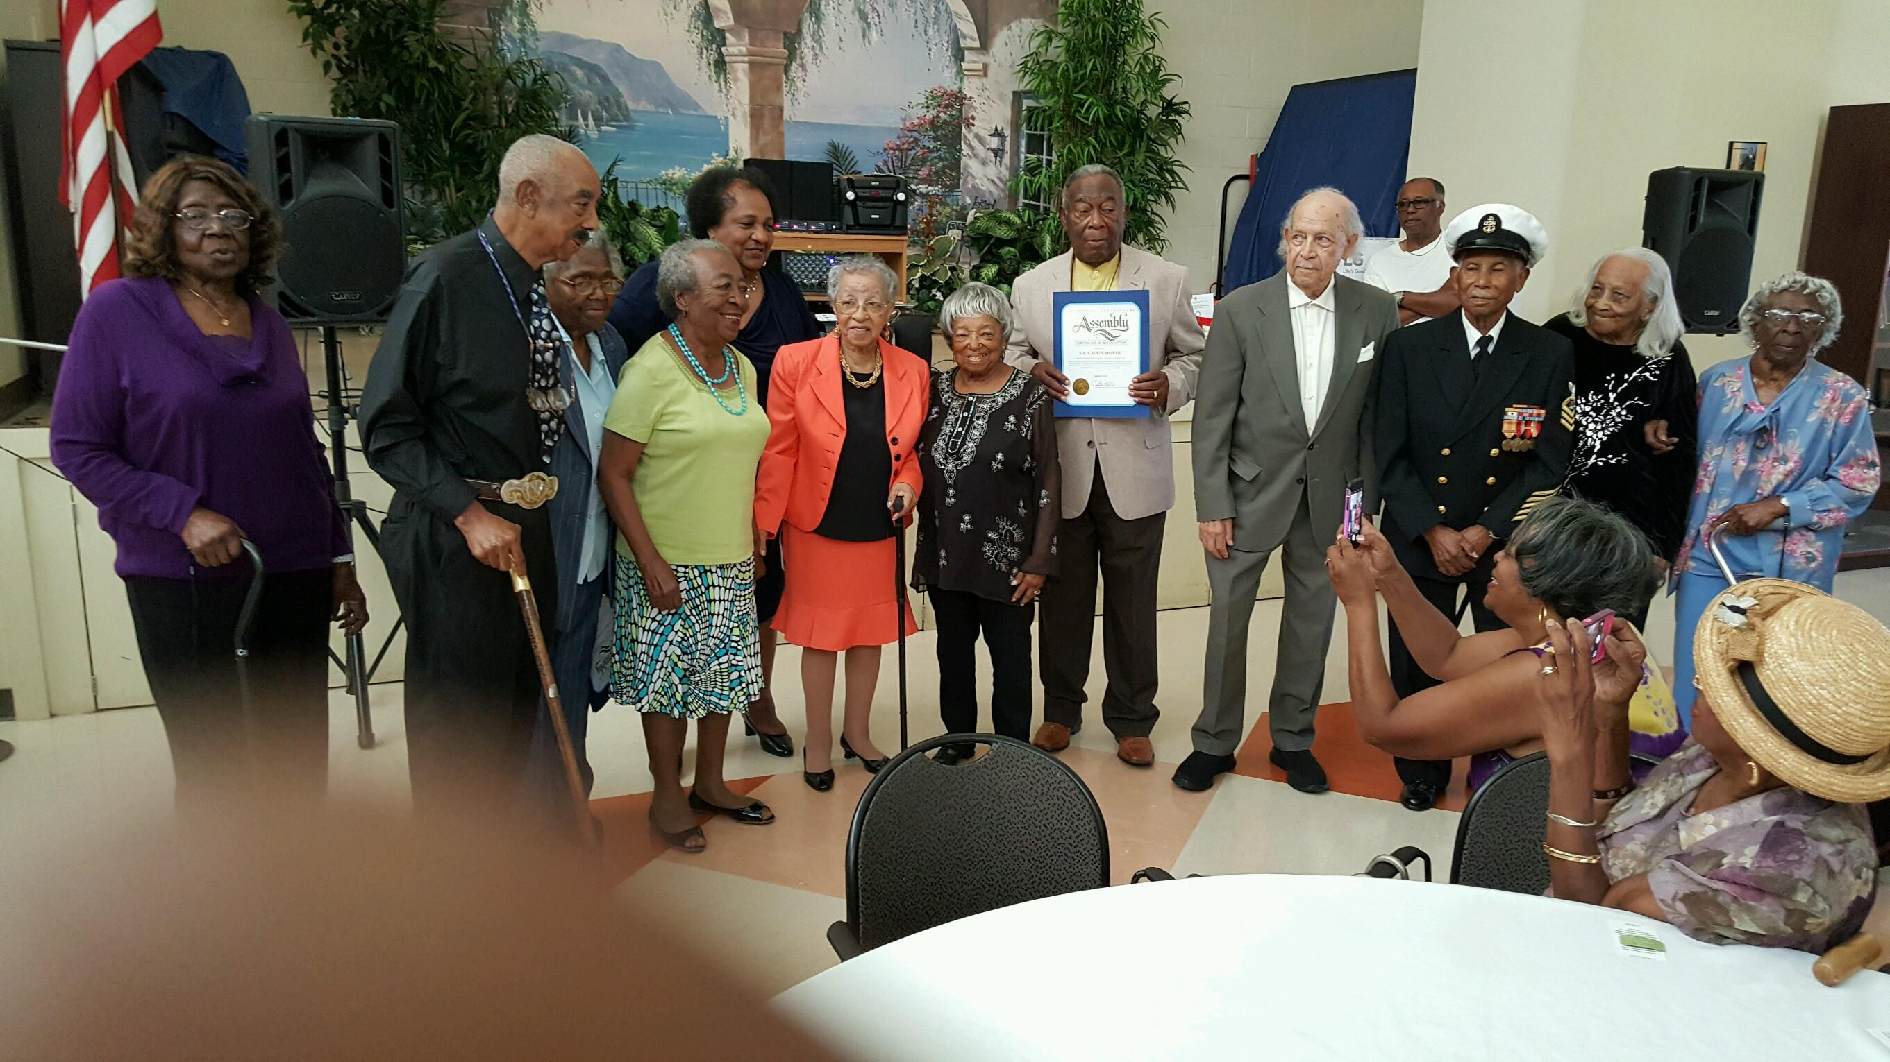
Fourth District Seniors Resource Center
September 9, 2016

