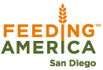
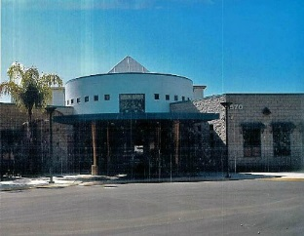
FOURTH DISTRICT SENIORS RESOURCE CENTER (FDSRC)
IN PARTNERSHIP WITH
FEEDING SAN DIEGO (FSD)

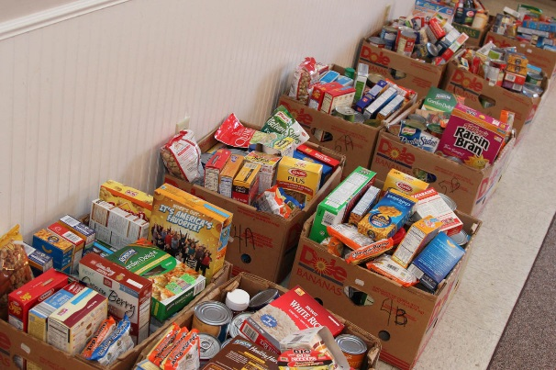
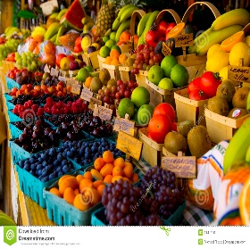
HEALTHY FOOD
DISTRIBUTION
FOR
SENIORS (60 YEARS PLUS)

WHEN: (4th Thursday each month)
WHERE: George L. Stevens Senior Center
570 S. 65th Street (Off Skyline Drive)
San Diego, CA. 92114
TIME: 12:30 – 3:30 P.M.

To register or for more information, please phone (619) 266-2066.

“WE SHARE BECAUSE WE CARE”

